Mission: Partnering with staff, students, and their families to create a safe, healthy, and inclusive learning environment that provides an enjoyable and positive experience for the entire school community.

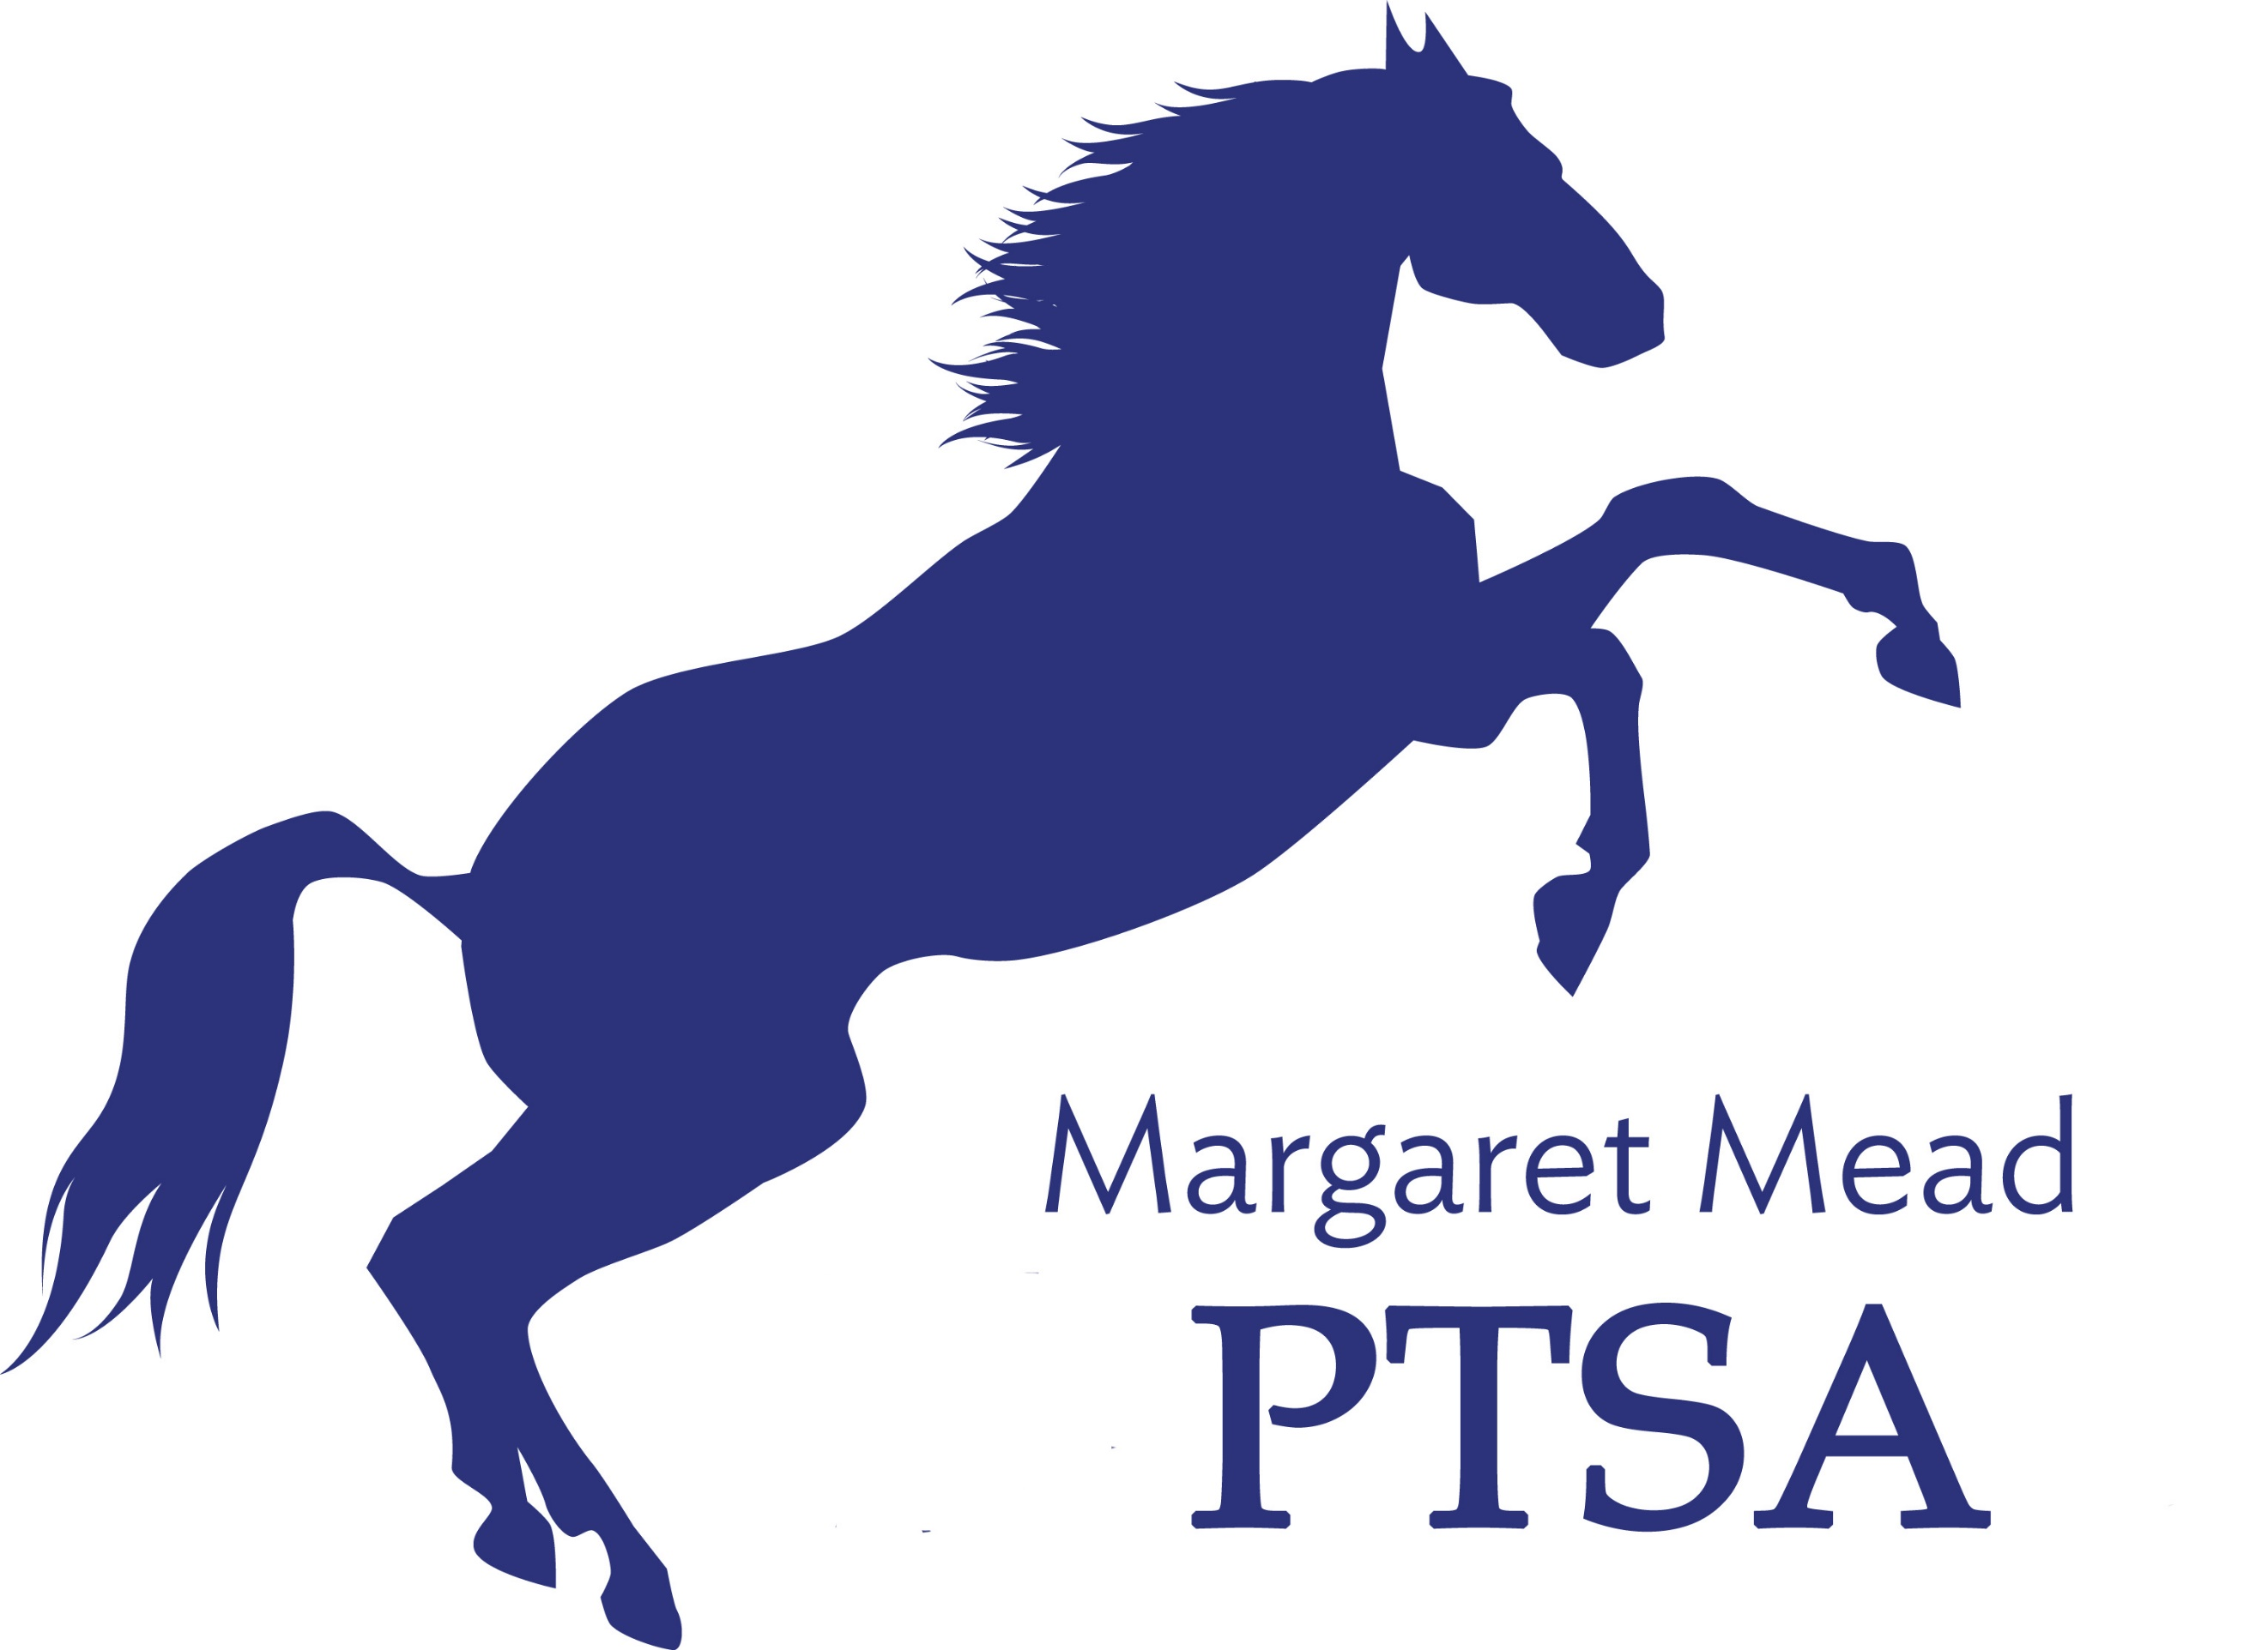



Margaret Mead Elementary PTSA  
1725 216th AVE NE, Sammamish, WA 98074  
PTSA Unit 2.8.38  
www.meadptsa.org





Margaret Mead Elementary PTSA  
1725 216th AVE NE, Sammamish, WA 98074  
PTSA Unit 2.8.38  
www.meadptsa.org

Goal: Support the mission statement using   
effective communication, connecting community, financial support & fiscal responsibility.

**General Membership Meeting MINUTES**  
**January 14, 2020**

Present: Leta Hamilton, Ryika Hooshangi, Abi Nubla-Kung, Molly Hylen, Liz Moore, Suzy Khendry, Niko Olsen, Daniella Toledo, Sharon Mason, Sandy Klein, Sarah Jensen, Sharon Wu, Ashwini Godbole, Kelsey Faucett, Heather Gibbons, Antoinette Haynes, Sue Gabica, Cassy Patterson, Trista Lofti, Ashley Arrington

**Call to Order 7:03pm**

Approval of the Minutes – Minutes approved into record

PresidentRyika Hooshangiwelcomed the Zoom attendees to the GMM.In-Person vs. Fully Remote school changes coming in February. However, we will be acting as one unified PTSA.

Mead was recently awarded at the Lake Washington PTSA Council level for its “How-to” Series. The How-To series started with Mr. Jamieson. Mrs. Klein & Mrs. Jensen have also done videos. Mrs. Baughman is doing “How to Make a Pie” tomorrow. Access the videos through the PTSA website for Facebook page.

International Night is coming up on March 4th. If anyone is interested in volunteering, please contact Ryika Hooshangi.

Sending out information soon about a new Yearbook format. If anyone wants to join the team, please reach out to Ryika Hooshangi.

Volunteer opportunities include the Board vacancy for Legislative/Advocacy position. We are also considering adding a New PTSA Board Member/Committee on inclusion and diversity at Mead. We are going to start exploring getting either a new board position or committee position focused on diversity and inclusion.

Vice President, Abi Nubla-Kung, shared that Bingo/Game Night coming up. There are 21 families signed up. There is a cap of 100 kids. Currently 27 kids (21 families) are signed up. Door prizes will be per family.

Spelling Bee is happening February 4 at 6pm. It coincides with a Board of Directors meeting. 56 students are registered for the Spelling Bee.

**Election of Nominating Committee for 2021-2022 school year.**

Ashley Arrington motioned to approve the slate for the Nominating Committee. Molly Hylen seconded. Nominating Committee members are Liz Moore, Ashwini Godbole, Leta Hamilton. There were no objections to the slate. Approved unanimously.

**Treasurer:** Molly Hylen reported that the Ending Balance from December is $98,159.72. Income and reimbursement activity was slow through December. We still have some unclaimed checks that Molly has cancelled. We got a matching fund check of around $3,000 in January. Molly also reported that the Mid-year audit is coming up.

**Principal/Staff Update**

Equity Team – At Mead, the Equity Team has been comprised of staff only the last couple of years. This year, we are adding 3 families. Mrs. Klein sent an email to the Mead community on January 14. The PTSA board may add an Equity & Inclusion position to their board.

Meeting Adjourned at 7:28pm Next General Membership Meeting—May 20, 2021 at 7:00pm

**Calendar of Events**

* Jan 21: BINGO/Game Night
* Feb. 4: Spelling Bee
* Feb. 4: Board Meeting (*potential date change)
* March 4: International Night
* March 11: Board Meeting
* April 15: Board Meeting
* April 29: Virtual Cooking Class
* May 3-7: Teacher Appreciation Week
* May 20: Board Meeting and General Membership Meeting
* June 3: Board Meeting
* June 16: Last Day of School